Task 01

Step 1: First we will create a void method to sort the array.
Step 2: We will start a for loop running from 1st index to the last index.
Step 3: Inside for loop, we will introduce an int variable “min” that will store i^th element as the smallest index.
Step 4: Inside for loop, we will run another for loop that will start from i+1 and will run till the n-1 element.
Step 5: Inside the second loop, we will pass a condition which will check whether the current element is smaller than our minimum element that we passed in first for loop.
Step 6: if it satisfies the condition, we will assign the current index to the “min” variable”.
Step 7: Outside the second loop, we will swap the current element with the min element.

Task 02

for(i = 0→N){
Min = i
fori(j=i+1→N-1){
if(arr[j]<arr[min]){
Min = j
}
}
swap(arr[i], arr[j])
}

Task 03
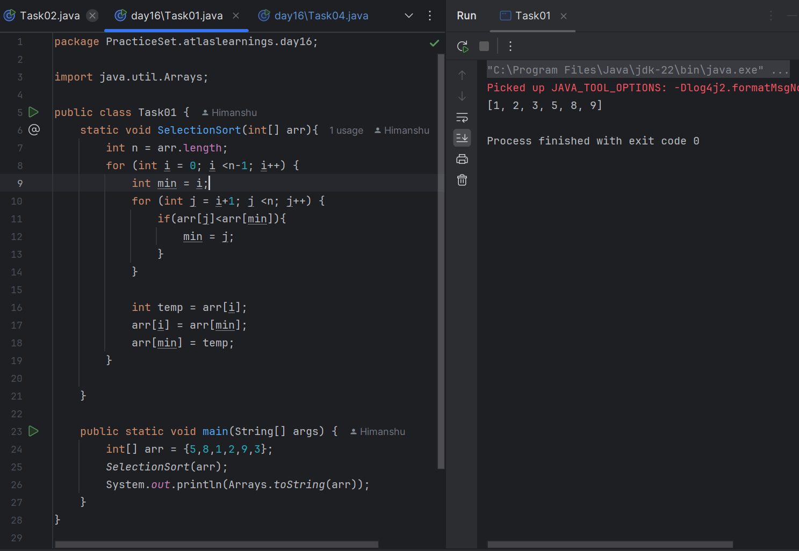
Task 04
Step 1: start loop from i= n-1 index to 0.
Step 2: start another loop inside the first loop that runs from 0th index to i.
Step 3: if the Jth element is greater than J+1th element, Swap.

Task 05
For(i=n-1→0){
for(j=0→i-1){
swap(arr[j], arr[j+1])
}
}

Task 06
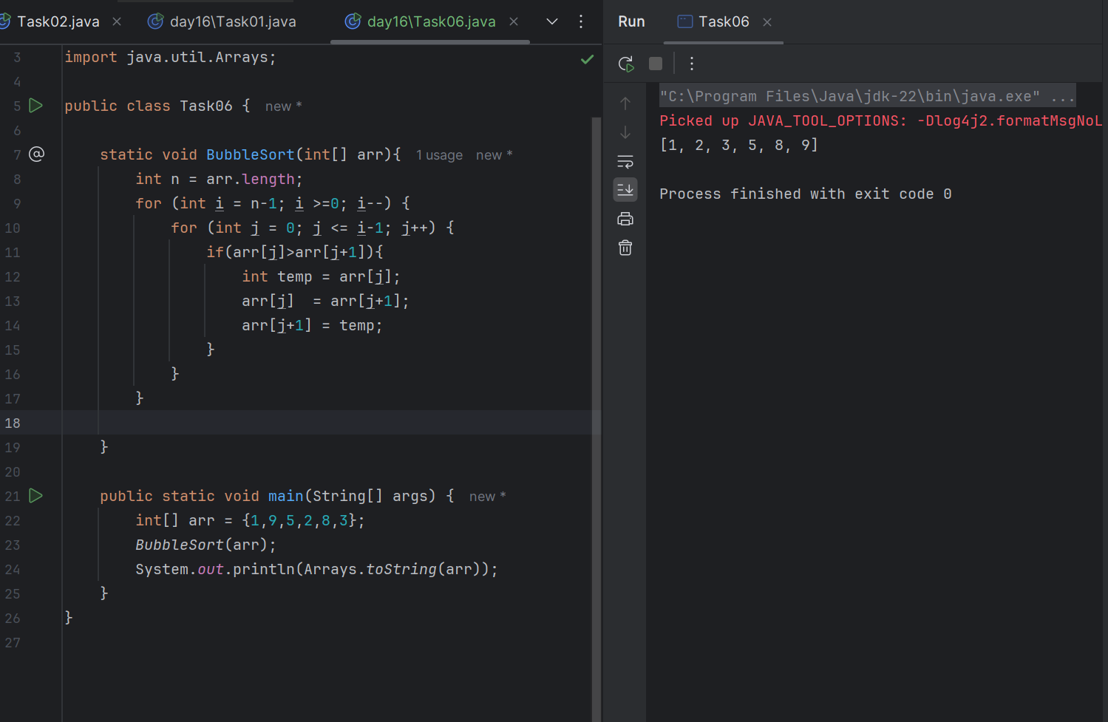
Task 07
Step 1: start for loop from 0th index to nth index.
Step 2: initialize a local variable j with value as ith index.
Step 3: start a while loop where j is always greater than 0 and Jth element is greater than the next element.
Step 4: Swap the J-1th element and jth element.
Step 5: reduce the j with 1;

Task 08
for(i =0 → n){
J = i;
while(j>0 && arr[j-1]>arr[j]){
Swap arr[j], arr[j-1]
j–;
}
}
Task 09
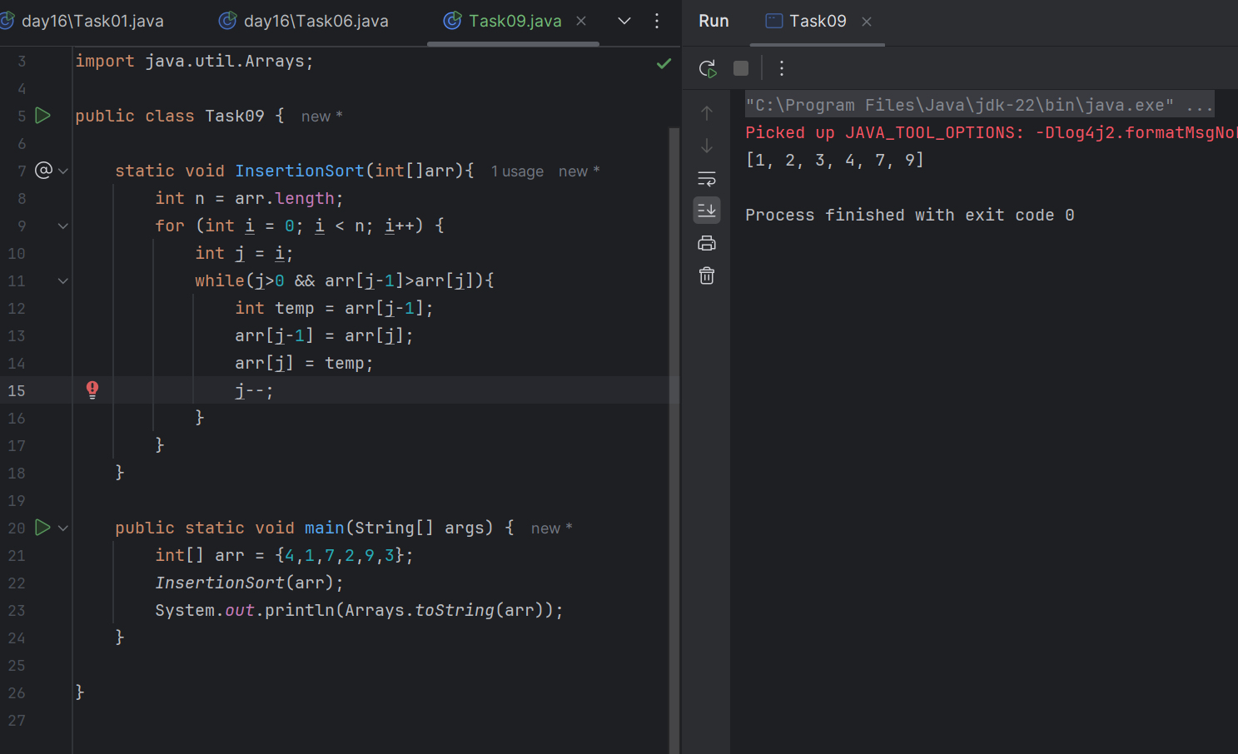
Task 10
Advantages of Bubble Sort
- Simple to implement
- In place sorting. Space complexity O(1).
- Maintains relative order of the equal elements
- Efficient for nearly sorted data.
Disadvantages of Bubble Sort
- Inefficient for large data sets
- Unnecessary comparison
- Performs worse than insertion sort, selection sort, merge sort, and quicksort in most scenarios.

Task 11
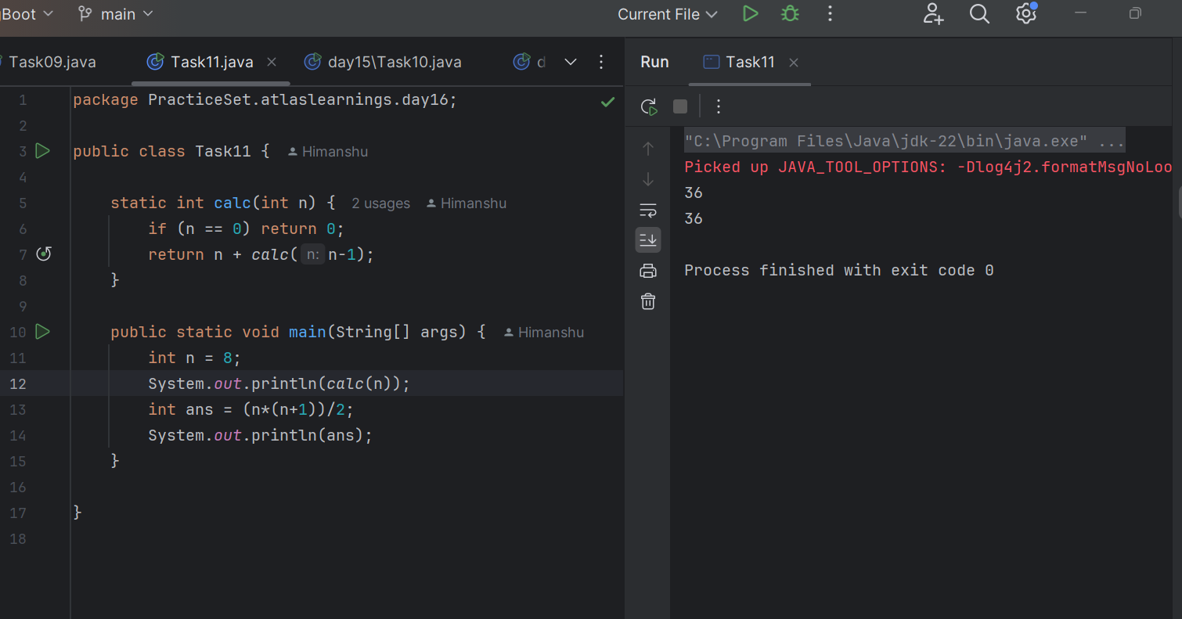

Task 12
MergeSort
Step 1: create a method with taking input as an Array, start index and last index.
Step 2 : write a base condition that it will return once loss crosses high.
Step 3: find the mid index.
Step 4: repeat the cycle with input as array, low index and mid index
Step 5: repeat the cycle with input as array, mid+1 and end index.
Step 6: merge the arrays
Step 7: write merge function and create a temp arraylist inside.
Step 8: take left pointer and right pointer.
Step 9: start a while loop which will run till array left <= mid and right<=high.
Step 10: compare left array and right array and add the element to the temp arraylist if it is smaller.
Step 11: add remaining elements from the bigger array to the temp arrayList.
Step 12: put all the elements back from temp arraylist to the array.

Task 13
function(arr, 0, n){
If low>=high return
Mid = (low+high)/2

function(arr, 0, mid)
function(arr, mid+1, n)
merge(arr, 0, mid, n)

}

merge(arr, 0, mid, n)
Arraylist = temp;
Left = 0;
Right = mid+1;
while(arr[left]<=mid && arr[right] <= n){
if(arr[left]<=arr[right]) temp.add(arr[left]){
left++
} else{
temp.add(arr[right])
right++;
}

while(left<=mid){
temp.add(arr[left])
left++;
}
while(right<=n){
temp.add(arr[right])
right++;
}
for(i = low; i<=high; i++){
Arr[i] = temp.get(i-low);
}
}

Task 14
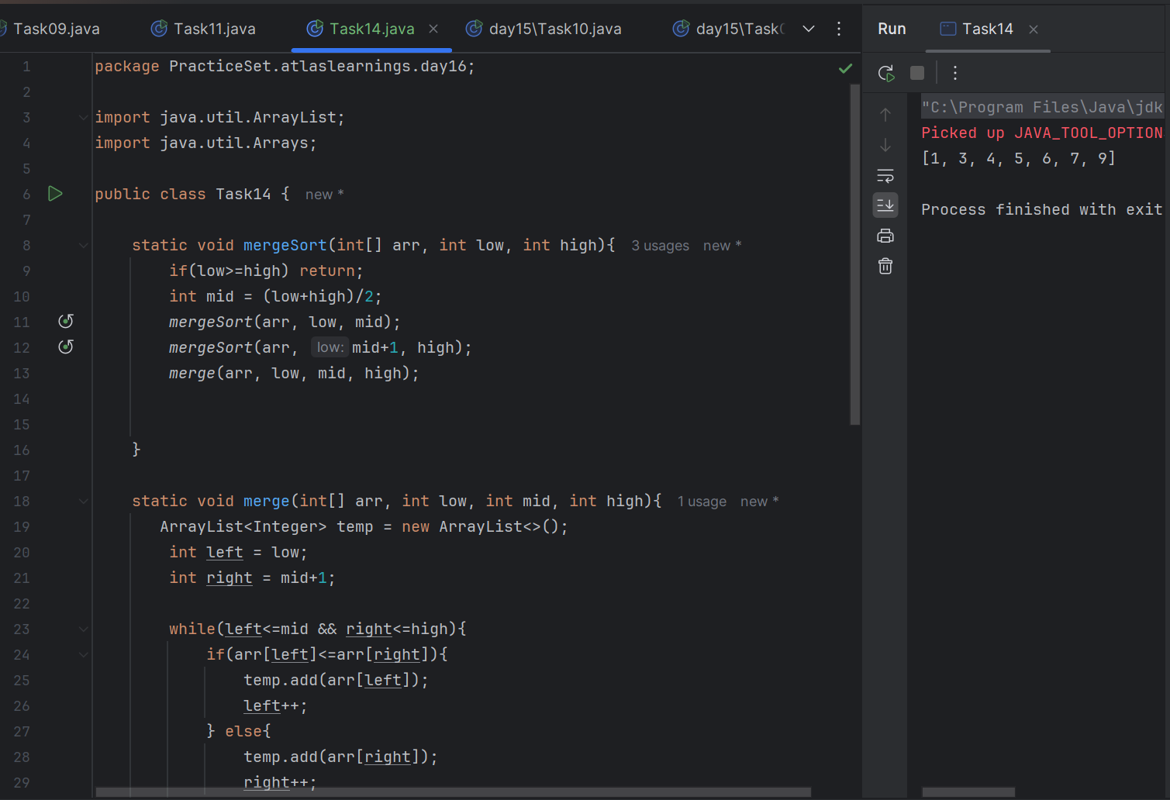
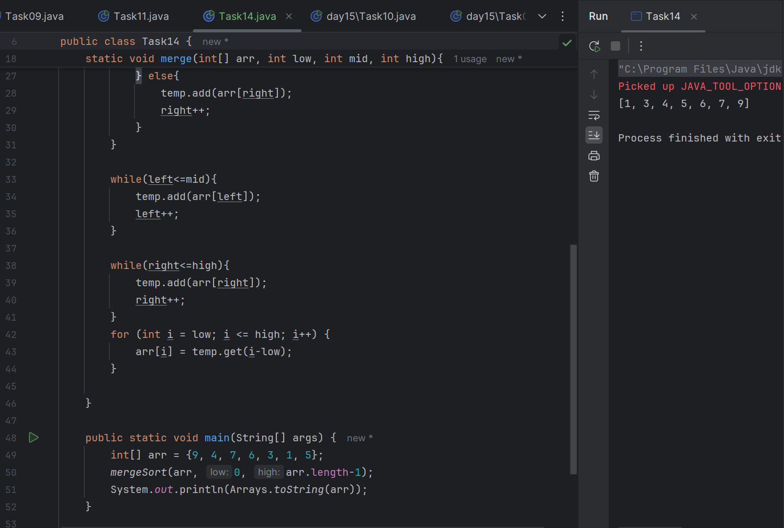
Task 15

Step 1: Take Array, low index and high index and find pivot Index first to sort the elements.
Step 2: create a partition method to find the partition index. Take Array, low index and high index.
Step 3: store pivot as first element.
Step 4: take 2 pointers as low and high to compare the elements. Low = 0, high = n-1;
Step 5: we will move from left to right till elements of the array are small or equal to the pivot.
Step 6: we will move from right to left with j pointer till elements of the array are greater than pivot.
Step 7: remaining elements will be swapped. Arr[i] and Arr[j].
Step 8: Outside this while loop, we can swap the jth element with first element to ensure everything on the left is smaller and everything on the right is greater than jth element.
Step 9: we will create a recursive method while low<high.
Step 10: the array will be divided basis on the low to pIndex -1 and pIndex+1 to high;

Task 16

quicksort(arr, low index, high index){
if(low<high){
Int partitionIndex = partition(arr, low, high)
quicksort(arr, low, partitionIndex-1)
quicksort(arr, partitionIndex+1)
}
}

partition(arr, low, high){
Pivot = arr[low]
I =low;
J = high

while(i<j){
while(arr[i]<=pivot && i<=high-1){
i++;
} while(arr[j]>pivot && j>low+1){
j–;
} if(i<j){
swap(arr[i],arr[j])
}

swap(arr[j], arr[low])
Return j;

}
}
Task 17
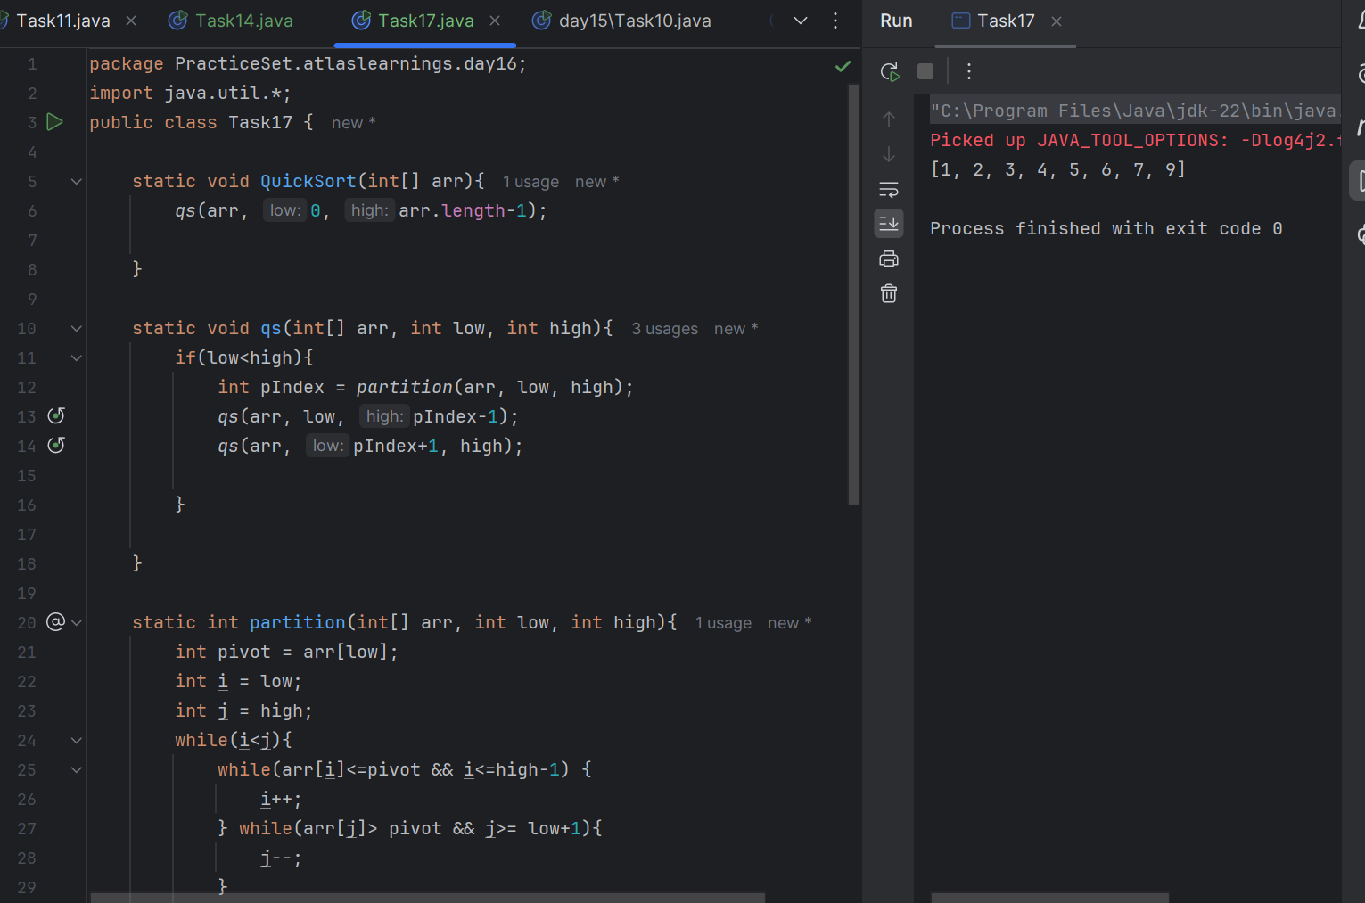
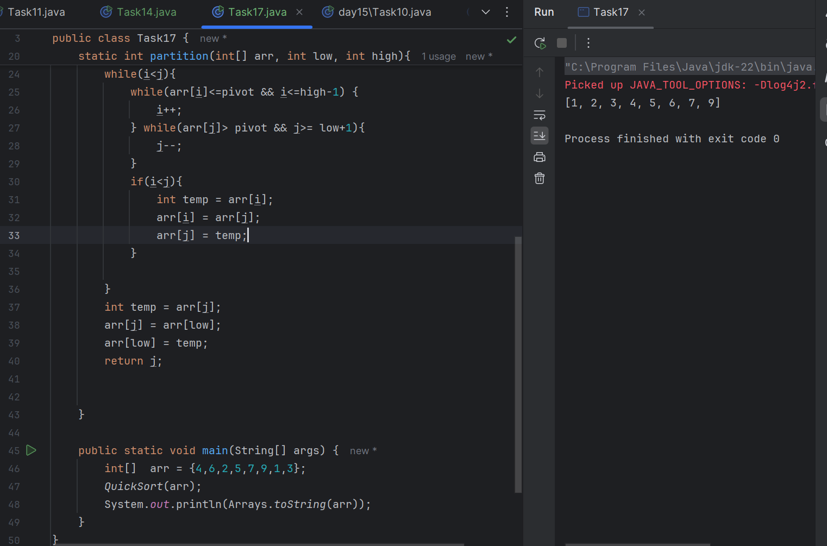
Add Ons:

What is the difference between binary tree and binary search tree (bst)

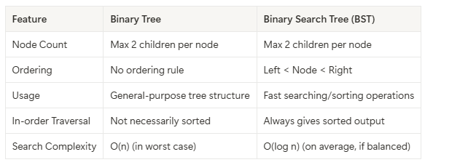

In sorted array why do you think binary search tree is better than linear search?
Linear Search Starts from the beginning of the array and checks each element one by one and Time Complexity: O(n) — worst case, you may have to look at every element.
While If you create a BST from a sorted array, and if it's balanced, you can Start from the root. At each step, eliminate half of the remaining nodes. Time Complexity: O(log n) (if tree is balanced).

Difference between static and dynamic arrays

Feature | Static Array | Dynamic Array
Size | Fixed at compile time | Can grow or shrink during runtime
Memory Allocation | Allocated at compile time (stack/heap) | Allocated at runtime (heap)
Resize Possible? | No (size cannot be changed) | Yes (size can be changed dynamically)
Performance | Faster (no overhead of resizing) | Slightly slower (due to resizing, copying)
Memory Usage | Efficient, but inflexible | May use extra memory (over-allocation)
Ease of Use | Simple but limited | More flexible and powerful
Example in Java | int[] arr = new int[10]; | ArrayList<Integer> arr = new ArrayList<>();

In BFS, DFS which one is more preferred in terms of shortest path for the unweighted graphs.

For finding the shortest path in an unweighted graph, Breadth-First Search (BFS) is preferred over DFS. In an unweighted graph, all edges are considered to have equal weight (1).
BFS explores the graph level by level, starting from the source node, so: The first time BFS reaches a node, it's via the shortest path (minimum number of edges). BFS guarantees the shortest path from the source to every reachable node.

